**Name of Student: Ramit Bose**

**Reg.No.: 21BCE1316**

**Ex. No:03**

**Date : 20-01-2023**

**Requirements Modeling using ER Diagram**

Aim: Creating ER diagram for my application ATM Management System using StarUML

Description:

Creating entities like Payment Mode, Customer, Customer Login, Payment and Transaction and establishing suitable relations between them to carry out the proper functionality of the ATM

Management system.

Output Screenshot:

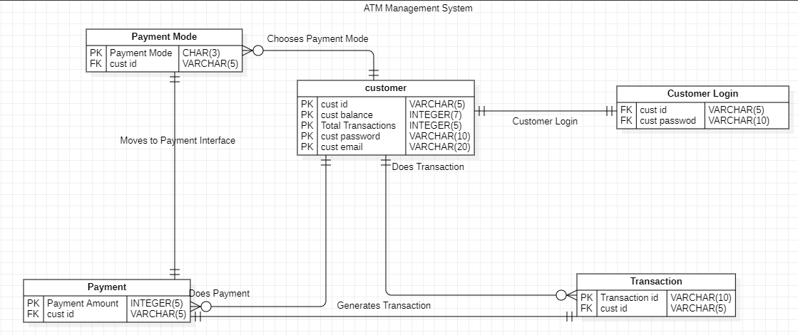

Result: The Diagram has been verified as successful by the lab faculty in-charge.